**7-Segment Display**

 introduction

7-segment displays are made up of 8 LED segments. They are used to display Numbers (0-9) and certain Alphabets (like c, A, H, P, etc.).7 of these LED segments are in the shape of a line, whereas 1 segment is circular.Each of the 8 elements has a pin associated with it which can be driven HIGH or LOW.To display a number or alphabet, we need to turn on specific LED segments of the display.

**Components:-**

* 7 segment LED display
* Arduino uno
* Resistors
* Breadboard

**Application**

**1. timers, clock radios, digital clocks, calculators and wristwatches**.

2.These devices can also be found in speedometers, motor-vehicle odometers, and radio frequency indicators.

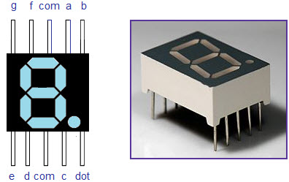O

**Objective**

During this activity ,you will help to achieve following objectives

* Understanding concept of seven segment display
* Design algorithm and flowchart to display numbers
* Programming an arduino
* Interfacing seven segment display with arduino.

Flow chart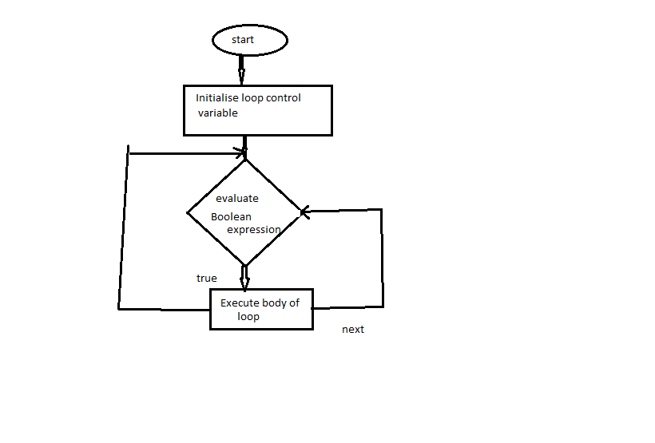

Programing

**void setup()**

**{**

**init();**

**}**

**void loop()**

**{**

**}**

**void init()**

**{**

**pinMode(2, OUTPUT);**

**pinMode(3, OUTPUT);**

**pinMode(4, OUTPUT);**

**pinMode(5, OUTPUT);**

**pinMode(6, OUTPUT);**

**pinMode(7, OUTPUT);**

**pinMode(8, OUTPUT);**

**pinMode(9, OUTPUT);**

**}**

**void display(int n=-1, boolean dp)**

**{**

**digitalWrite(9, !dp);**

**if(num == 0)**

**{**

**digitalWrite(2, 0);**

**digitalWrite(3, 0);**

**digitalWrite(4, 0);**

**digitalWrite(5, 0);**

**digitalWrite(6, 0);**

**digitalWrite(7, 0);**

**digitalWrite(8, 1);**

**} else if(num == 1) {**

**digitalWrite(2, 1);**

**digitalWrite(3, 0);**

**digitalWrite(4, 0);**

**digitalWrite(5, 1);**

**digitalWrite(6, 1);**

**digitalWrite(7, 1);**

**digitalWrite(8, 1);**

**} else if(num == 2) {**

**digitalWrite(2, 0);**

**digitalWrite(3, 0);**

**digitalWrite(4, 1);**

**digitalWrite(5, 0);**

**digitalWrite(6, 0);**

**digitalWrite(7, 1);**

**digitalWrite(8, 0);**

**} else if(num == 3) {**

**digitalWrite(2, 0);**

**digitalWrite(3, 0);**

**digitalWrite(4, 0);**

**digitalWrite(5, 0);**

**digitalWrite(6, 1);**

**digitalWrite(7, 1);**

**digitalWrite(8, 0);**

**} else if(num == 4) {**

**digitalWrite(2, 1);**

**digitalWrite(3, 0);**

**digitalWrite(4, 0);**

**digitalWrite(5, 1);**

**digitalWrite(6, 1);**

**digitalWrite(7, 0);**

**digitalWrite(8, 0);**

**} else if(num == 5) {**

**digitalWrite(2, 0);**

**digitalWrite(3, 1);**

**digitalWrite(4, 0);**

**digitalWrite(5, 0);**

**digitalWrite(6, 1);**

**digitalWrite(7, 0);**

**digitalWrite(8, 0);**

**} else if(num == 6) {**

**digitalWrite(2, 0);**

**digitalWrite(3, 1);**

**digitalWrite(4, 0);**

**digitalWrite(5, 0);**

**digitalWrite(6, 0);**

**digitalWrite(7, 0);**

**digitalWrite(8, 0);**

**} else if(num == 7) {**

**digitalWrite(2, 0);**

**digitalWrite(3, 0);**

**digitalWrite(4, 0);**

**digitalWrite(5, 1);**

**digitalWrite(6, 1);**

**digitalWrite(7, 1);**

**digitalWrite(8, 1);**

**} else if(num == 8) {**

**digitalWrite(2, 0);**

**digitalWrite(3, 0);**

**digitalWrite(4, 0);**

**digitalWrite(5, 0);**

**digitalWrite(6, 0);**

**digitalWrite(7, 0);**

**digitalWrite(8, 0);**

**} else if(num == 9) {**

**digitalWrite(2, 0);**

**digitalWrite(3, 0);**

**digitalWrite(4, 0);**

**digitalWrite(5, 0);**

**digitalWrite(6, 1);**

**digitalWrite(7, 0);**

**digitalWrite(8, 0);**

**} else if(num == 10) {**

**digitalWrite(2, 0);**

**digitalWrite(3, 0);**

**digitalWrite(4, 0);**

**digitalWrite(5, 1);**

**digitalWrite(6, 0);**

**digitalWrite(7, 0);**

**digitalWrite(8, 0);**

**} else if(num == 11) {**

**digitalWrite(2, 1);**

**digitalWrite(3, 1);**

**digitalWrite(4, 0);**

**digitalWrite(5, 0);**

**digitalWrite(6, 0);**

**digitalWrite(7, 0);**

**digitalWrite(8, 0);**

**} else if(num == 12) {**

**digitalWrite(2, 0);**

**digitalWrite(3, 1);**

**digitalWrite(4, 1);**

**digitalWrite(5, 0);**

**digitalWrite(6, 0);**

**digitalWrite(7, 0);**

**digitalWrite(8, 1);**

**} else if(num == 13) {**

**digitalWrite(2, 1);**

**digitalWrite(3, 0);**

**digitalWrite(4, 0);**

**digitalWrite(5, 0);**

**digitalWrite(6, 0);**

**digitalWrite(7, 1);**

**digitalWrite(8, 0);**

**} else if(num == 14) {**

**digitalWrite(2, 0);**

**digitalWrite(3, 1);**

**digitalWrite(4, 1);**

**digitalWrite(5, 0);**

**digitalWrite(6, 0);**

**digitalWrite(7, 0);**

**digitalWrite(8, 0);**

**} else if(num == 15) {**

**digitalWrite(2, 0);**

**digitalWrite(3, 1);**

**digitalWrite(4, 1);**

**digitalWrite(5, 1);**

**digitalWrite(6, 0);**

**digitalWrite(7, 0);**

**digitalWrite(8, 0);**

**} else {**

**digitalWrite(2, 1);**

**digitalWrite(3, 1);**

**digitalWrite(4, 1);**

**digitalWrite(5, 1);**

**digitalWrite(6, 1);**

**digitalWrite(7, 1);**

**digitalWrite(8, 1);**

**}**

**}**

Hardware

In this circuit, the pins of seven-segment display are connected to Arduino pins 2-9, as shown in the table below. Common pins (pin 3 and pin 8) are connected to GND and dp is left unconnected, because it is not used in this experiment

|  |
| --- |
|  |

|  |  |
| --- | --- |
| **Seven segment pins** | **Arduino pins** |
| 1(e) | 6 |
| 2(d) | 5 |
| 3,8(COM) | GND |
| C | 4 |
| 5(dp) | - |
| 6(b) | 7 |
| 7(a) | 8 |
| 9(f) | 7 |
| 10(g) | 8 |

